Weather Planning Document

**Site Name:**

Final Forecast finalforescast.com

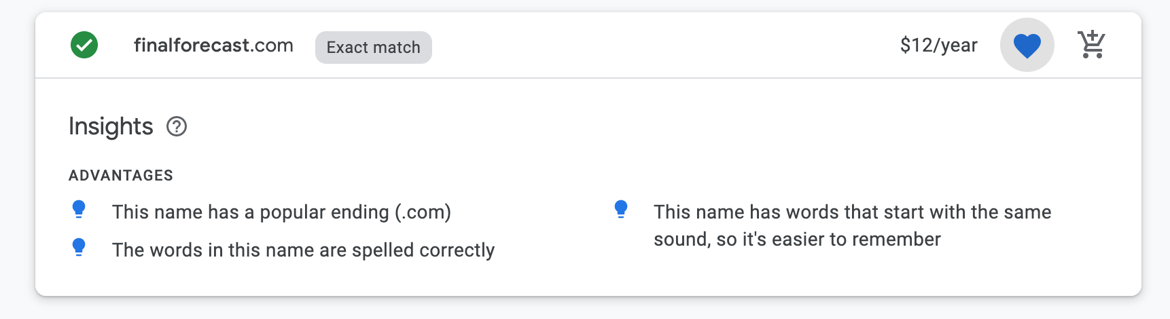



**Site Purpose:**

The purpose of this site is to be a source of final weather information. An accurate simple weather forecast will be provided to help people decide if they should do certain activities, wear certain clothes, or go to certain places. In particular, this is a site to let athletes know which sport will be best for that day.

**Target Audience:**

People who want to do some sort of recreational activity or sport and want to know if the weather will be appropriate.

Steven Johnson

31 years old

Father and Husband

Usually uses mobile device to check

Favorite Sports: Golfing, Mountain Biking

Steven wants to go golfing and wants there to be no wind with clear skies. He particularly wants to know about the morning right after the sunrise.

Clara Hoffman

24 years old

College Student

Uses mobile device to check weather in the evening

Favorite Sports: road biking, soccer

Clara checks weather last minute to see if it is safe to ride her road bike on the streets in the afternoon. She wants it be free from rain or snow, but doesn’t mind if it is on the cold side.

Hillary Smith

80 years old

Retired and grandmother

Uses desktop to check the weather every morning

Favorite Sports: Swimming

Hillary swims every morning with her friends. She wants to make sure there is no thunder storms, but doesn’t mind the rain.

**Scenarios:**

I want to go swimming in my local outdoor pool but it looks stormy outside. If it rains, will there lightning?

I am going to compete in a cycling race that will last all day. What clothes should I bring to be prepared?

I have asthma and need updated every morning to know if I should wear a mask or not. Even with asthma, I also like to go for long morning walks. How smoky is it outside?

I love golfing but don’t want to practice my golf swing with wind being a factor. When will the wind die down?

My bike is chained up outside by my apartment. Should I bring it inside so it doesn’t get weathered?

I want to go surfing but am worried that it will be too cold because we are going into winter. Is 6am too cold to go surfing?

**Site Map:**

**NOT REQUIRED**

**Color Scheme:**

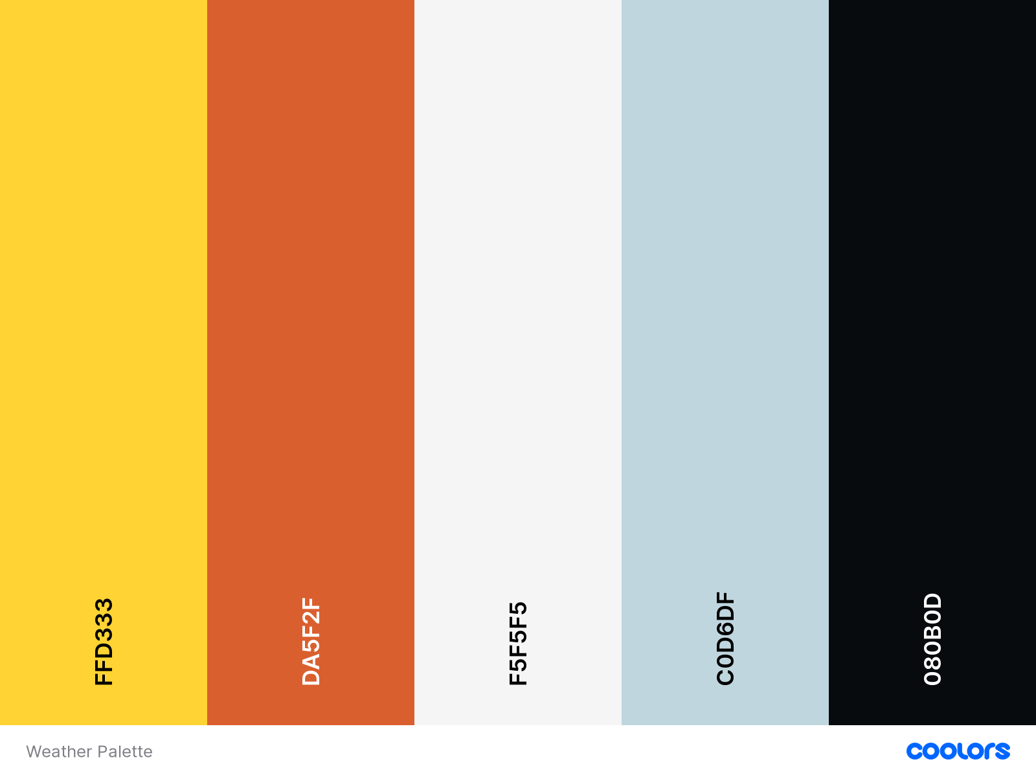

*Cyber Yellow*

*Flame*

*Cultured*

*Columbia Blue*

*Rich Black FOGRA 39*

Cyber Yellow will be used for backgrounds and small details.

Orange can be used as a font color or detail on borders and navigation bar.

Cultured will be the overall background color.

Columbia Blue will also be a good color for the header/footer or logo colors.

Rich Black is a great text color.

**Typography:**

To embed a font, copy the code into the <head> of your html

<link>@import

<link href="https://fonts.googleapis.com/css2?family=**Passion+One:wght@700**&family=**Poppins:wght@300**&display=swap" rel="stylesheet">

CSS rules to specify families

1. font-family: 'Passion One', cursive;

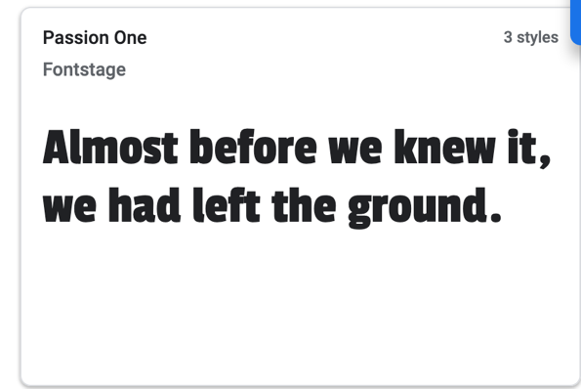

Passion one can be used for titles, headers, etc.

1. font-family: 'Poppins', sans-serif;

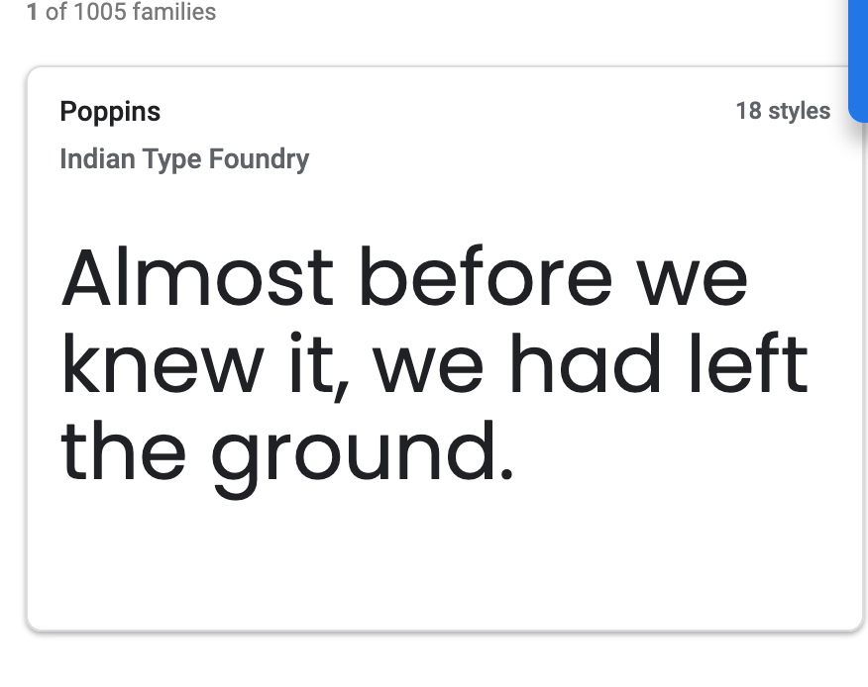

**Poppins can be used for paragraphs, menus, navigation, etc.**